

MKT Idea to Business Plan

Project Report: BooXchange



Submitted to: Prof Paragi Shah

|  |  |  |
| --- | --- | --- |
| **Name** | **Roll Number** | **Program** |
| Jainam Chhatbar | AU1741002 | BTech ICT, 6th Sem |
| Aman Dave [Project Manager] | AU1741003 | BTech ICT, 6th Sem |
| Harshiv Patel | AU1741005 | BTech ICT, 6th Sem |
| Charmil Gandhi | AU1741059 | BTech ICT, 6th Sem |
| Krishna Patel | AU1613031 | IMBA, 8th Sem |
| Prachi Shah | AU1613044 | IMBA, 8th Sem |

|  |  |  |
| --- | --- | --- |
| Sr.No | Content | Pg. No |
| 1. | Purpose and Plan |  |
|  | 1.1 Target Market | 4 |
|  | 1.2 SWOT Analysis | 4 |
| 2. | Value Proposition | 7 |
| 3. | Smoke Testing |  |
|  | 3.1 Assumption Testing | 9 |
|  | 3.2 Phase 1 | 10 |
|  | 3.3 Phase 2 | 12 |
| 4 | Business Canvas Model |  |
|  | 4.1 Detail Plan | 14 |
|  | 4.2 Assumptions | 17 |
| 5. | Marketing Plan |  |
|  | 5.1 Market Penetration Strategy | 27 |
|  | 5.2 Index Strategy Comparison: | 28 |
|  | 5.3 Future plan for next five years | 30 |
| 6. | Financial Plan |  |
| 7. | Questionnaire | 35 |
| 8. | Terms and condition | 36 |

# **Chapter 1: Purpose and Plan**

Every year many books are thrown away or kept unused in your desk and many people don’t know what to do about it. People go to book-stores and try to sell it there but they treat you with reasons that it won’t sell or is old-version and in turn give you less money because they consider their commission. Now what we can do about it is we can have a platform where anyone can post the book, provide its details and ask to sell or exchange it. First, any user looking for the book will be asked what city they need the seller to be in and then he/she can search for the book they’re looking for and can get what they want at reasonable prices with the ease of access to sellers and to their convenience

Most of us don’t go through the textbooks during the entire semester. They will use the textbooks one week prior to the exams only. This means that buying a book for the entire semester is not the most efficient way. One other thing we have observed is, not all universities have the exam at the same time.

Taking into the prior two assumptions in mind, we thought of creating a platform for students where they can share the textbooks as and when needed.

**Why would you choose BooXchange:**

1. Student A from University X has exams during the first week of December. Another Student B from University Y has exams during the last week of December. Here, student A needs a book but it is not available in his University library, while it is available at B’s University library. What A can do is put up a request for the book on our platform and B can take that request, issue the book on his behalf and send A, the book for a pre-decided period of time.
   1. Student A gets his book when he needs it.
   2. Student B can earn a small amount of money without doing anything. (We are not sure about the legal consequence of this right now)
2. Student A and Student B from the same University but different years. Student B can put up a request describing the books he has and Student A can then take it from him.
3. Once you have read a novel, most people won’t read it again. But they might prefer to own it. So instead of reselling it, they might want to lend it to someone for a few time and earn some quick bucks.
4. Can order books from anywhere. It could even provide Incentives for the customer as they would be giving their book for rent and thus earning from the same.

## 1.1 Target Market

For the first phase of the launch of “BooXchange” we plan to focus on:

* The engineering students and the management students of two universities of Ahmedabad University i.e. Ahmedabad University and Gujarat University can exchange books on this platform. In the later stage more universities will be added in the target segment.
* The management students of Ahmedabad University have to buy many course-packs as a study material designed by faculties. So these students will also be the target customers of BooXchange as the students who have already bought a course-pack can share their course-packs with other students who are currently enrolled in the course.
* Through this platform bibliophiles can rent their novel to others as the people who loves to read books are not willing to sell their novel. So such people who are willing to share their books will also be the target customers.

## 1.2 SWOT Analysis

**Strengths**

* ***Books available at low cost***

For a book which a customer needs for a short amount of time, he should get an inexpensive option.

* ***Second-hand books***

Second-hand books available with highlighted important points or some notes and corrections.

* ***Reduce Time***

No long-line to rent a book from the library.

Can order books from anywhere

* ***Easy Access***

Not go to the library just to be told the book is not available.

* ***Variety***

In terms of genre and editions.

Availability of different genres and editions.

* ***Making money***

Customers can make money by lending books to others.

**Weakness**

* **Reliability**
* **copyright**

**Threats**

* ***Buying costly books***

They have to pay the full price of the book of which they are going to use only for a limited-period of time.

* ***E-Books***

Due to lack of availability of hard-copy, people resort to buying e-books which are cheaper sometimes.

* ***Issuing books available in Library***

**Opportunities**

* ***Cost of buying a book that is being used for 2 weeks***

Students usually turn to books only when exams are approaching and do not touch them otherwise.

* ***Long waiting time to get books***

Students may have to wait for a longer time to borrow books from the university library due to very limited stock.

People may have to wander from market to market in search of particular book

* ***Different editions than they need***

Due to less stocks of books or due to urgency, people are compromised to buy any edition books.

* ***Waiting time for books to be delivered***

People have to look for various sources like Amazon to get their books which takes time to get delivered to them.

* ***E-books***

Readers prefer the feel of smelling a physical book, scribbling in it, the sensory value of holding it and it’s easy to share with friends.

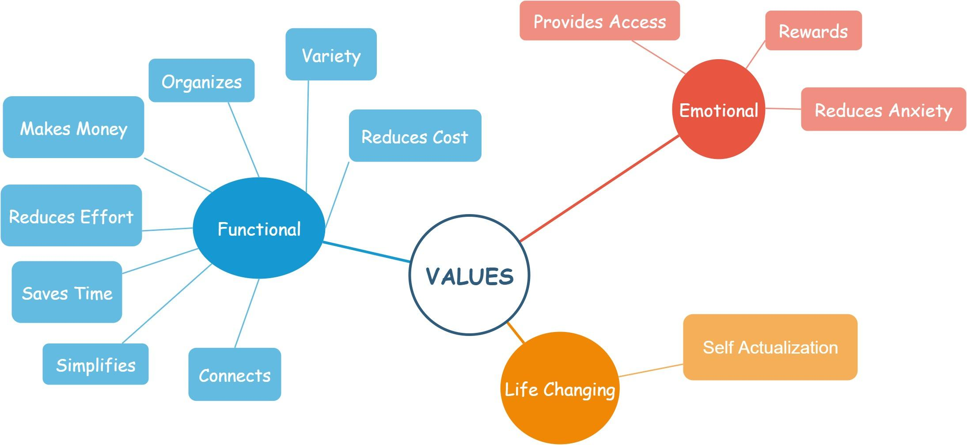

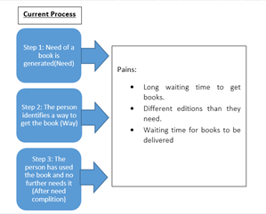

### 

# **Chapter 2: Value Proposition**

## Customer segment

* **Gains**
  + 1. Low cost
    2. Already Highlighted points
    3. Variety in terms of genres/editions
    4. Easy access to available sources
* **Customer Jobs**
  + 1. Identify the source of books
    2. Wait when a lack of availability of books
    3. Order/ buy them
* **Pains**
  + 1. Anxiety to get books when in need
    2. Full cost to be paid for a book that is needed for a few weeks
    3. Textbooks are not always helpful

## Value Proposition

* **Gain Creators**
  + 1. Earn quick cash
    2. Get notes from scholars
    3. Tutoring sessions
    4. Wider access to variety of books
* **Pain Relievers**
  + 1. No anxiety/stress of whether the book is available
    2. Cost advantage
    3. Tutors for specific topics
* **Products and Services**
  + 1. Rent Textbooks:
    2. Rent Novels/Storybooks
    3. Rent Handwritten notes
    4. Course-pack
    5. Book a session with tutor

|  |
| --- |
|  |
|  |

# **Chapter 3: Smoke Testing**

## 3.1 Assumption Testing

## **List Of Assumptions**

1. Same textbooks across different universities would be available in their library(1st)
2. People are willing to lend their books for a short time to earn quick bucks (2nd)
3. Students are willing to pay some amount of money for a given time (4th)
4. Exams of different universities are not at the same time i.e. non-congruent (2nd)
5. Sellers post accurate info about their books (4th)
6. The delivery of book between the buyer and seller would be a smooth process (4th)
7. Students are willing to pay some amount for small tutor sessions (4th)
8. Seniors are willing to use our platform to give out their books to their juniors so as to earn some quick cash (1st)

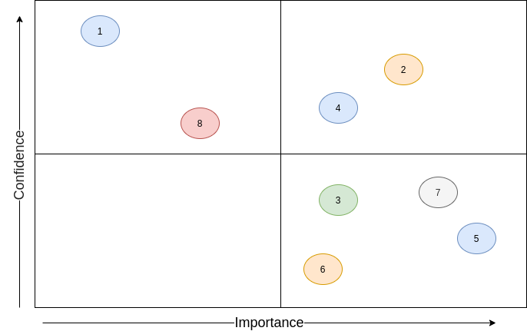

## 3.2 Phase – 1

* What are we testing / objectives ?
  + People will rent their books for some quick bucks.
  + Students are facing difficulties in issuing books from library
  + Handwritten notes along with textbooks will help to prepare better for exams
  + What are people preferring :
    1. Buying new textbooks
    2. Use second hand books
    3. Renting books
* The Complete Methodology / Duration, Sample Size / Instrument
  + We made a questionnaire and circulated in different colleges and recorded the responses from different students.
  + *Duration :* 1 week
  + *Sample Size :* 40 students
  + *Instrument :* Questionnaire circulated using Google Forms

***Why Google Form ?***

Easy to circulate and data interpretation is a lot easier

* What will we know at the end ?
  + The frequency with which students prepare for the exams

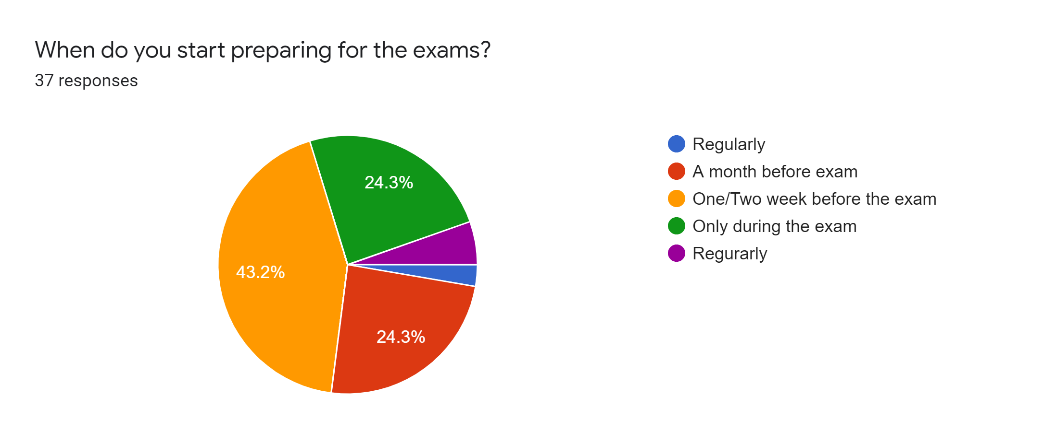

* + Students prefer used books and renting books more over buying new books.

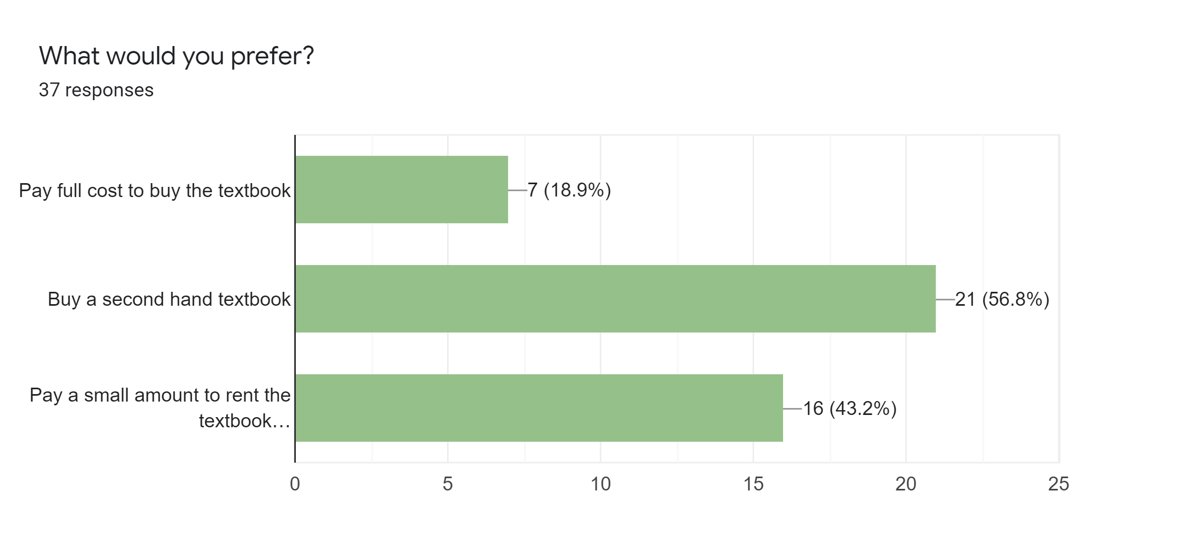

* + Most students think that just preparing from textbooks during exams does not help prepare well.

But handwritten notes and textbooks do ***(33 out of 37 students i.e 89.2%)***.

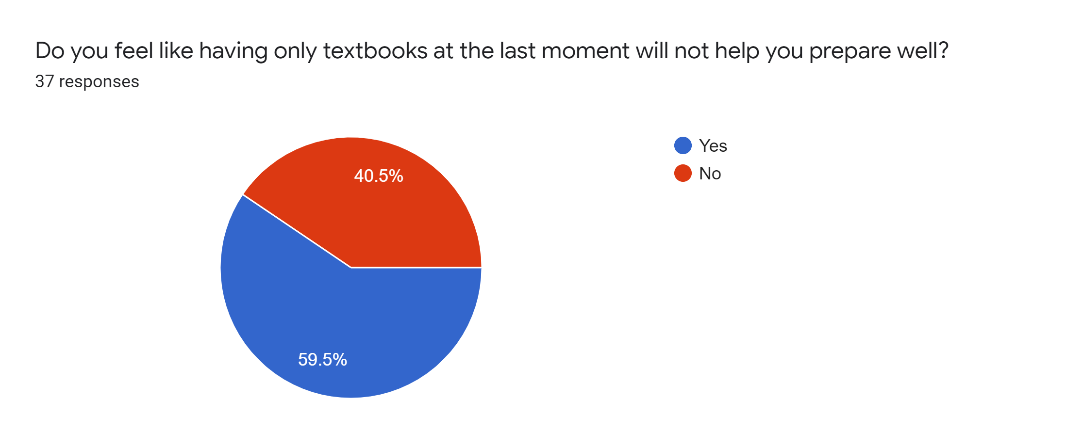

* + We collected a list of strong subjects/topics as well as weak subjects/topics and observed that most students want tutorial sessions for weak topics/subjects.

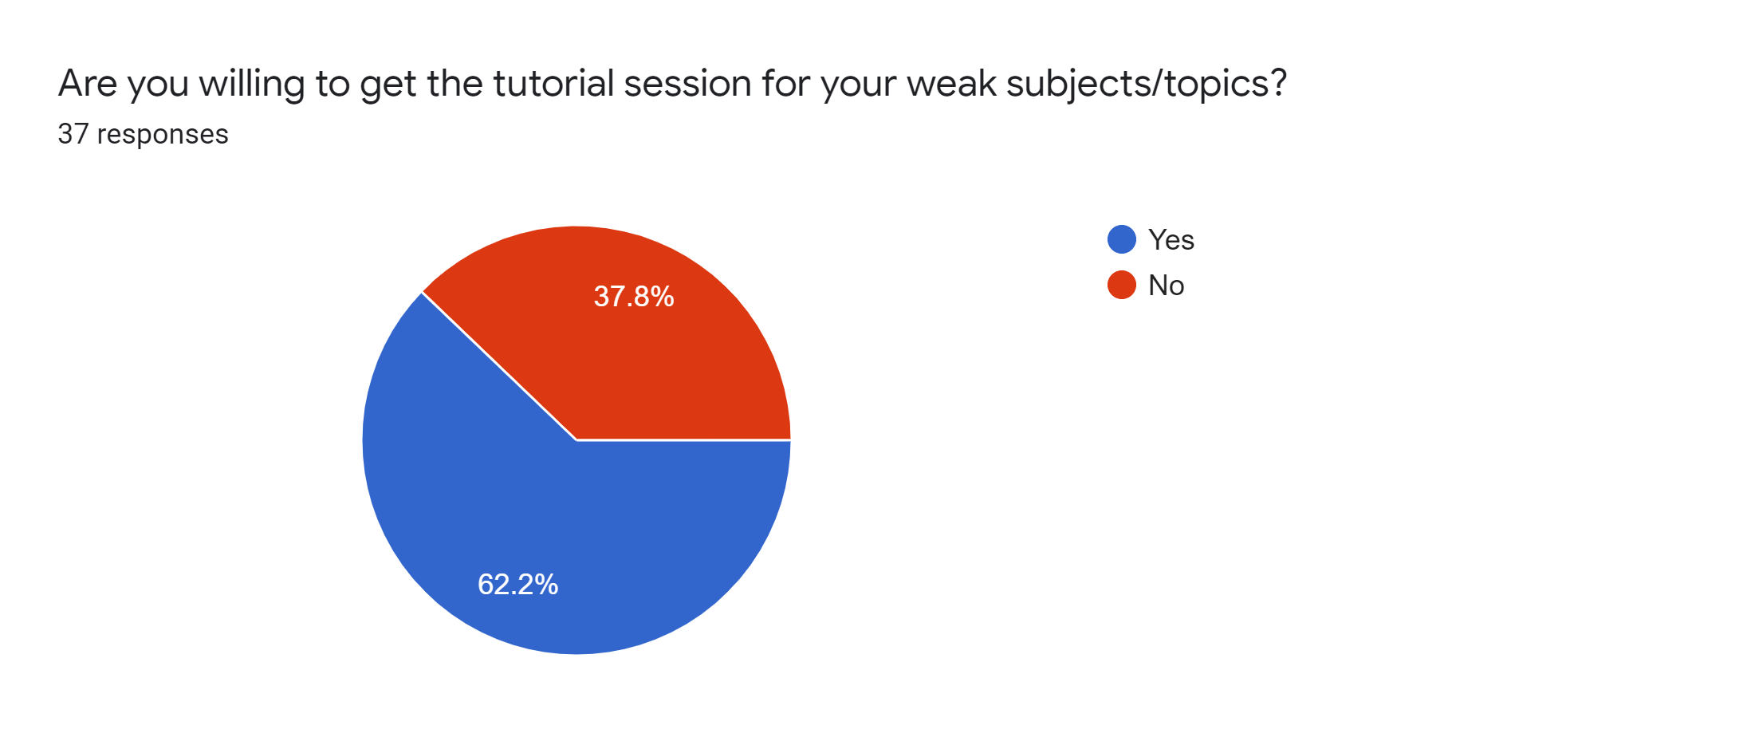

We also observed that the majority of the students are interested in renting their books using our platform. 25 out of 37 students are interested i.e ***67.6%***

* When / What will I know that we are right ?
  + This was an initial pilot survey. We wanted to know the market before diving deep. Hence, there is no point of being right or wrong here.

## 3.3 Phase – 2

In ***PHASE-1,*** The strategy was to circulate the google form and conduct a pilot survey. To get more insights for our assumptions, we are initiating phase 2 with three different strategies.

* What are we testing / objectives ?
  + Students are genuinely willing to rent their books for a token amount of money
  + Students are willing to share their handwritten notes for some quick bucks
  + Students are willing to give tutorial sessions
* The Complete Methodology / Duration, Sample Size / Instrument
  + ***Contact all the interested students and make a whatsapp group***

Here students can post their book request in whatsapp group and can directly come in contact with the one who is willing to lend the book.

* + ***Give few pre-owned books to those in need for token amount***

We will make a list of a few books that our team owns. Share that list with others and ask them for a minimal token amount. We will record their entire experience along with their feedback.

* + **Duration:** 2 - 3 weeks
  + **Sample Size:** 25 - 30 students that exchange books with us as intermediaries
* What will we know at the end ?
  + The entire process of taking a book on rent and then giving it back
  + How often are the transactions happening
  + Do we have enough books to run the business
* When / What will I know that we are right ?
  + Depending on the feedback of the initial users, we can have an estimate of the process including the conditions of the book returned.

## 

## Process after smoke test

* We have collected 40 responses from various Universities / Colleges. Out of these responses, 27 students are interested in using our platform to exchange their books.
* We will send mail to the interested students with an invitation link to our whatsapp group.
* Information about the list of books / notes is available with us and our close friends will be shared in the whatsapp group.
* Members will ask the admins for the books / notes they want for what duration and token amount (for example Rs.10 to start with).
* The members from distant universities will have to collect their requested books / notes from School Of Engineering and Applied Science, Ahmedabad University.
* The members from Ahmedabad University and nearby universities (for example L.D College) will be delivered their requested books / notes by us to their university
* Members can request tutorials and also show their interests in providing one to the admins. Also, we or our close friends can provide requested tutorials for some amount. (can be free initially)

# **Chapter 4: Business Canvas Model**

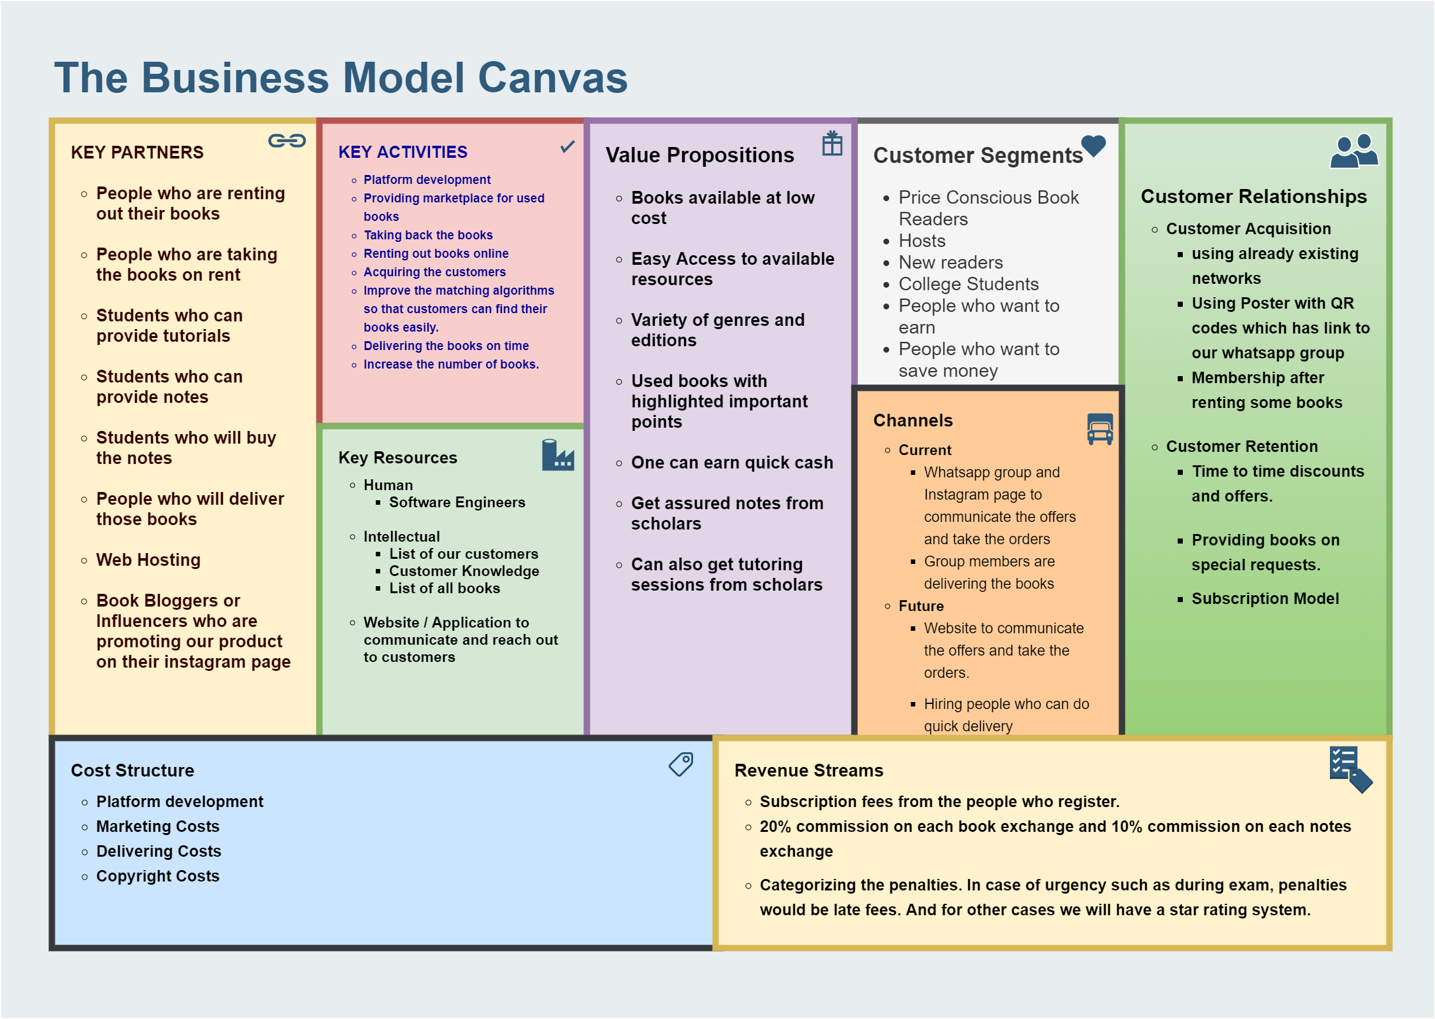

## 4.1 Detail Plan

* ***Value Proposition:***
* Books available at low cost
* Easy Access to available resources
* Variety of genres and editions
* Used books with highlighted important points
* One can earn quick cash
* Get assured notes from scholars
* Can also get tutoring sessions from scholars
* ***Customer Segment***
  + **Price Conscious Book Readers**

Find range of books available on rent at affordable prices

* + **Hosts**

Attracting people who want to give their books and notes on rent

* + **New readers**

People who are planning to start reading books might want to try 2-3 books before investing big amounts in the books

* + **College Students**

Students who are in the Engineering and Management degrees who want to get good grades with help of notes and textbooks and perform better academically.

* + **People who want to earn**

People who want to earn small amounts by renting books and notes

* + **People who want to save money**

People who want to save money can avoid buying costly books

* ***Channels***
  + **Current**

Whatsapp group and Instagram page to communicate the offers and take the orders

Group members are delivering the books

* + **Future**

Website to communicate the offers and take the orders.

Hiring people who can do quick delivery.

* ***Customer Relationship***
  + **Customer Acquisition**

By using already existing networks (Bird in Hand)

Using Poster with QR codes which has link to our whatsapp group

Making people our members after they have rented out some amount of books

* + **Customer Retention**

Providing time to time discounts and offers.

Providing books on special requests.

Also we will have a subscription model

* ***Revenue Model***
  + Subscription fees from the people who register.
  + 20% commission on each book exchange and 10% commission on each notes exchange
  + Also we can categorize the penalties. In case of urgency such as during the exam, penalties would be late fees. And for other cases we will have a star rating system.
* ***Key Resources***
  + **Human**

Software Engineers

Marketing Executives

Delivery person

* + **Intellectual**

List of our customers

* + **Customer knowledge**
  + **List of all the books**
  + **Website / Application to communicate and reach out to customers**
* ***Key Partners***
  + People who are renting out their books
  + People who are taking the books on rent
  + Students who can provide tutorials
  + Students who can provide note
  + Students who will buy the notes
  + People who will deliver those books
  + Web Hosting
  + Book Bloggers or Influencers who are promoting our product on their instagram page
* ***Key Activities***
  + Platform development
  + Providing marketplace for used books
  + Taking back the books
  + Renting out books online
  + Acquiring the customers
  + Trying to improve the matching algorithms so that customers can find their books easily.
  + Delivering the books on time (Service)
  + Trying to increase the number of books.
* **Cost Structure**
  + **Platform development:**

Cost incurred to build and host the website and constantly update and maintain it.

* + **Marketing**

Cost incurred to attract and retain the customers

Discounts can also be our costs.

* + **Delivering Costs**

Logistic cost which is incurred during the delivering the service

Fuel cost of delivery person

* + **Copyright Costs**

Cost incurred during implying copyright laws on the rented notes and book

## 

## 4.2 Business Canvas Model: Assumptions

### **Customer Segments**

1. **Segment Dimension**

* ***Customer segment:*** Multi-sided
* Asset Sharing Platform
* ***Supply side:*** Increase utilization of the books and notes and earn additional income
* ***Demand Side:*** Help to find books which they can rent at a low price

1. **Segment Composition**

* Graduate/ Undergraduate
* Once-in-a-blue-moon readers
* People who do not invest in books
* Price Conscious Book Readers
* Attracting people who want to give their books and notes on rent
* People who are planning to start reading books might want to try 2-3 books before investing big amounts in the books
* Students who are in the Engineering and Management degrees who want to get good grades with help of notes and textbooks and perform better academically.
* People who want to earn
* People who want to save money

**Consumers** **For**

Academic Books

Non-academic books

Tutoring

**Lenders For**

Academic Books

Non-academic books

Tutoring

**Assumptions**

### **From the survey**

* ***Total responses :*** 44
* ***People interested in a platform for books and notes :*** 30
* ***Conversion rate :*** 68.2%

**From the smoke test**

* Total Participants in the whatsapp group : 80 (Started with 25 members with classmates)
* Age-group: Maximum number of followers are from the age group of 18-24
* Total number of orders : 43
* Orders for academic books: 9
* Orders for non academic books: 34
* Total number of members who gave books on rent : 10
* Conversion rate for the people who give on rent: 12.5%
* Total number of members who took the book on rent: 16
* Conversion rate for the people who took the book on rent: 20%
* Most attracted segment : The most attracted segment were the people who are novel readers as per the smoke test
* Most popular product list : Self- Help was the most popular genre from the novels.
* Total followers on instagram : 104
* Number of orders on instagram : 4
* Age-group: Maximum number of followers are from the age group of 18-24
* Conversion rate : 3.8%

**Secondary data:**

* Number of students graduating each year (Ahmedabad University) : 3204
* Number of students graduating each year (L.D College): approx 4000
* Number of students graduating each year (IIM): approx 3600
* Number of students graduating each year (IIM): approx 3750
* Total Number Of Students: 14,551
* Number of total students in bachelors (As per the above given data and assuming that the degree is of 4 years) = 14,551*4 = 58,204 (approx 58,000)

### **2**. **Value Proposition**

|  |  |
| --- | --- |
| **Every participant gets something back** | |
| **The person who takes on rent** | **The person who gives on rent** |
| 1) Books will be easily available | 1) Can earn quick cash |
| 2) Books available at low cost | 2) Becomes a part of book-readers community |

## How are we different?

* ***Olx*** , ***Amazon*** or retail booksellers provide less money to the seller when reselling the item and charge close to the actual price of it to the buyer. We provide the owners an opportunity to keep the ownership of books and still earn money by giving out on rent.

The other markets take time to get delivered and they cost a lot because the user has to buy it. We allow the users to rent the books/notes and so they don’t have to pay the full amount of the item for a one-time use of notes/textbooks or just try out a book.

**Unique Values**

***Convenience:*** Readers can check the availability of their books without going out to the shops.

***Flexibility:*** They can rent out the books instead of buying costly new books or second hand books.

***Low Cost:*** They don’t have to pay the full price for one time use or trying out a novel/ textbook.

### **3. Channels**

* ***Multiple segments***
* ***Promotion and marketing channels:*** Instagram, Word of mouth Marketing, Posters
* ***Sales channel:*** Whatsapp, Instagram
* ***Distribution channel:*** Members of the team (Delivering staff)
* ***Location to be reached:*** To customer place or mutually decided place: ***Ahmedabad***
  1. *Students of Ahmedabad University and nearby colleges are delivered by us.*
  2. *Students from far away regions might have to meet up at decided places.*

Initially,

**Members in reach:** 25 members on whatsapp

**Expected orders:** 5

**Conversion rate:** 20%

**Till date,**

**Members in reach:**  104 ***(Instagram***) 80 ***(Whatsapp)***

**Orders :** 43

### **4. Customer Relationship**

* **Customer Acquisition**
  1. By using already existing networks ***(Bird in Hand)***
  2. Using Poster with QR codes which has link to our whatsapp group
  3. Making people our members after they have rented out some amount of books
* **Customer Retention**
  1. Providing time to time discounts and offers.
  2. Providing books on special requests.
  3. Also we will have a subscription model
  4. To retain the customers there will be late fees only for a few books or during some period of high demand like during exams otherwise no late fees charged. Instead a rating system will be developed so that the owner of the book can rate the person who has taken the book on rent.

**If there is a query who solves it ?**

Anyone can reach out to the founders via our website, whatsapp group or instagram page and can also post queries on the platform.

|  |
| --- |
| **Step 1:** Query arises |
| ***Step 2: Reach out to us through our website, whatsapp or instagram page*** |
| ***Step 3: The person in charge will reach back to you***   |  |  | | --- | --- | | **Issue** | **Tentative solution if there are no other conditions. The solutions might change looking at the situation** | | 1. If the customer do not return the book | -The customer will get very low rating and negative feedback  -The customer will not be allowed to order again  -The deposited amount of 20 rupees will be given to the book owner and the defaulter will be asked to give the amount equivalent to the cost of the book.  (The decision will be taken looking at the situation and after requesting the customer to return the book) | | 1. If the book gets damage | -The customer’s rating will be affected and so it will be difficult for the customer in their next order.  -The customer will lose the deposit amount of 20rs and will have to pay the amount equivalent to the book in case of full damage. | |
| **Step 4:** The issue will be resolved in no time |

### **5. Key Activities**

|  |  |  |  |
| --- | --- | --- | --- |
| **Activity** | **In-House/Outsource** | **Key Resource/ Key partner** | **Assumptions** |
| Acquiring the customers | In-house | Key Resource - Marketing team | This activity will be in-house and will be carried out by the marketing team |
| Providing Marketplace for Used Books | In-House | Key Resource- Technical team and online platform | People will rent their books to others.  People will take others books on rent. |
| Renting Out Books Online | In-House | Key resource - Online platform | People will take the book on rent at the price of 30rs per week as tested in the smoke test week |
| Taking back the books | In-House | Key resource - Delivering staff | People will return the book on time or they will reissue the books |
| Delivering Activity | In-house | Key resource- Courier/Delivery staff | The delivery of book between the buyer and seller would be a smooth process |
| Trying to increase number of books | In-House | Key Resource- Marketing | We assume that the number of customer will keep on increasing |
| Platform Development | In-House | Key Resource- Software Engineers |  |
| Record maintenance | In-house | Key Resource - software and staff |  |
| Trying to improve matching algorithm so that customers can find books easily | In-House | Key Resource - website |  |

### **Key Resources**

|  |  |  |
| --- | --- | --- |
| **Resources** | | **Assumptions** |
|  | |  |
| 1)Humans | Software engineers:  Delivery person:  Marketing staff:  Record keeping | One- time investment  We have in-house team of the people who will be developing the online platform   * The team of owners have software engineering and skills for developing the website * This will be their share   Routine servicing  For routine servicing and updation of the website a department will be made initially of 3 people. (Salary for these 3 can be between 5,000 to 24,000)  In-house staff will be hired to deliver the books. The requirement is that the delivering staff should have their own vehicle to deliver and per month 500rs will be given as fuel cost and commission will be given per delivery (The commission will be different on basis of the delivering location)  One- time investment  We have in-house team of the people who will be acquiring the customers   * The team of owners have marketing team and skills for attracting customers * This will be their share   Routine servicing  For routine advertising a team will be made initially of 3 people. (Salary for these 3 can be between 5,000 to 16,000)  A team of 2 people will be hired to record all the data and to present the data at the end of every month (The salary range here will be of 5,000 t0 11,000) |
| 2)Intellectuals | maintain database of customer  maintain database of book | Including their personal ratings  Including their orders  Including which books are preferred during which time of the year |
| 3  )Website | To keep customer engaged and take necessary orders  To know about which books are available |  |

# 

# 

# 

# **Key Partners**

|  |  |
| --- | --- |
| **Partners** | **Information** |
| People who will be giving on rent | **Assumed number**  Out of the target audience of 58,000, 7250 students will get ready to put their books on rent.  (According to the smoke test there are 10 people out of 80 who gave their books on rent so the rate is of 12.5%) |
| People who will take the books on rent | **Assumed number**  Out of the target audience of 58,000, 11600 students will get ready to take the books on rent.  (According to the smoke test there are 16 people out of 80 who gave their books on rent so the rate is of 20% ) |

## 

## 

## Assumptions

|  |  |  |
| --- | --- | --- |
| **Assumptions** | **Calculation** | **Rational** |
| 1. Working Hours | Total service hours = 24*26 = 624 | Renting services will available for 24 hours and for 26 days in a month  The customers can give their request for the book at any time and the next day the book will be delivered to them. The book will not be delivered on sundays and on national holidays. |
| 1. Costing strategy | 1) Per book cost  = (50-20) = 30  50: Deposit 20: Return  30: Charged  From this 10 will be kept within the business and 20 will be given to the owner of the book | This was decided through the smoke test as we tried to change the cost but the maximum orders were placed at this price. |
| 1. Customer Acquisition Cost | If to attract 80 members we incurred the cost of (450+200) = 650.  So to attract customer from 58,000 target audience, the cost can be of:  Approximately 4,70,000 rs | During the smoke test we acquired the customers by two main strategy   1. Posters/Marketing   Cost incurred = 200rs   1. Free books offer   15*30 = 450 rs |

**Demand and supply**

|  |  |
| --- | --- |
| Demand | Supply |
| **Actual data from the smoke test** | **Actual data from the smoke test** |
| Total number of orders = 43 | Total number of books available on rent = 95 |
| Orders for academic books = 9 | Number of academic books available = 14 |
| Orders for non-academic books = 34 | Number of academic books available = 81 |
| **Assumption on basis of the target audience** | **Assumption on basis of the target audience** |
| If in the smoke test 16 people out of 80 gave the book on rent, then the average number of books given on rent by the people will be approx 3  So assuming that there will be 11600 students who will take the books on rent. | So we will have to keep the supply ready on basis of the demand |
| Total number of orders assumed = 34,800 | Total number of books = 77,000 (Approx) |
| Orders for academic books = 34,800*0.209 = 7,300(approx) | Orders for academic = 11,000 (Approx) |
| Orders for non-academic books = 34,800*0.790 = 27,000 (approx) | Orders for non-academic = 64,000 (approx) |

Here 10 out of 80 people have kept the books on rent and so the average number of books per person will be approximately 4. Therefore to have 77,000 books, approximately 19,000 customers will be needed on the platform who will be giving the books on rent.

# **Chapter 5 : Marketing plan**

# **5.1 Market penetration strategy**

|  |  |  |
| --- | --- | --- |
| **Segment** | **Strategy** | **Factor Identified** |
| College Students | Collaborating with the clubs in different colleges. College students might not have much time and so our delivery service at their comfortable place will help them. | Time |
| New Readers | Variety of the books available  We have more than 100 books currently on the list so increasing the list can attract the new readers. | Costs and experience |
| Price conscious readers | Providing books at a price which is much lower than buying the books. | Costs |
| People who give books on rent | They get a chance to earn money by giving books on rent.Our strategy is to attract this segment as this is the segment which will help us to increase the list of books. | Competition and Price |
| People who want to rent | They want to save money | Cost which is price for the people who are giving books on rent |

## 

## 5.2 IndexStrategy Comparison: BooXchange vs Competitors

|  |  |  |  |
| --- | --- | --- | --- |
| Sr.No | **Factors** | **Competitors strategy** | **BookXchange Strategy** |
| 1. | Time | E-commerce sites: if prime then next day delivery or maximum about 5-6 days | Specific timings- If order given before 3.pm then delivery would be done on the same day.  Maximum one-day delivery |
| 2. | Competition | **Book shops:** They consider the full amount of books and return 40% back when we return it.  **Library:** Need to go back to the library for re-issue every week | Re-issue could be easily done .  Minimal rent of the book |
| 3. | Costs | Maintenance cost  Quality cost  Infrastructure cost | Delivery Cost: Keeping it as minimal as possible  **Quality Checking Cost:** Quality check of the books to be done on lending and returning the book  No warehouse or inventory management cost |
| 4. | Investment | **Book shops:**  place or shop  stock of varied book  4-5 employees for finding and selling the books  Warehouse  **Library:**  Librarian  Well established silent place  Reading room  warehouse  **E-commerce sites:**  Well established website  Delivery persons and delivery vehicles  warehouse | Website or established portal for the transaction  Delivery person  Quality check Person |
| 5. | Experience | Library and bookshops  Ratings are not provided. People tend to buy books and pay hefty amounts for the same.  Use and check strategy | The Best in second hand books  Could choose the best genre book through rating and guidance of the various readers. |

**5.3 Future Plan for next Five years**

Year 1:

|  |  |  |  |  |
| --- | --- | --- | --- | --- |
| **Year** | **Number** | **Rationale** | **Strategy** | |
| Year 1  **Main strategy**   * College Events * Instagram | Number of books = 10,000  Number of people who will give books of rent = 3000  For this we have to promote our business in 4 universities and we have assumed that there are 24,000 part of different clubs in these 4 universities combined | Here as the total students of   1. IIMA 2. LD 3. AU 4. GU   Is assumed to be 58,000 as mentioned in the assumptions and also every year arouad 15,000 new students will be entering thes universities so from this we assume that we will attract almost 2000 students from all these 4 universities from their clubs combined will be attracted to this service.  So from the rate derived during assumptions we can say that around 10,000 books can be added on the list. | Connecting with college students through their clubs and sponsoring college events.  Arranging events with the clubs like literary clubs.  At this stage we will try to make the college students aware in these 4 targeted universities and we will be giving offers targeted to this group.  To stay connected with this people we will stay them updated through our instagram page |
| Year 2  **Main strategy**   * College Events * Instagram * Gujarati Literature Clubs | Number of books = 25,000  Number of people who will give the books of rent = 5000 customers will be targeted | We will need 5,000 customers to reach the level where there will be 25,000 books available for the people to select from.  Here there will be 10,000 books so we assume that there will be 5% attrition. So 100 customers will leave our services.  So we will have to attract 3,500 customers to our platform. From this 2000 customers will again be from universities. 500 will be the people who like to read gujarati books as we will make our platform open for gujarati books.  We will try to attract 1000 through social media.  We will be use services like Priyanshi Patel’s “Ahmedabad Book Club” in which there are over 17,000 online members. | Ahmedabad Book Club is the largest community which is dedicated to literature.  By targeting this club we will reach a wide range of people.  Gujarati books can be from the customers who have interest in gujarati literature  Social media influencers who blogs about books will be contacted to reach people |
| Year 3  **Main strategy**  In Ahmedabad   * College Events * Instagram * Gujarati Literature Clubs   In Baroda  In Gandhinagar | Total number of books in the system = 40,000  There will already be  8000 customers this year. | We would already be having 5000 customers do we will have to attract other 3000 customers to our portal  Assuming a rate of 5% so 250 customers would leave our services.  So 3250 customers will have to be attracted.  Here 500 customers will be from colleges.  750 customers will be more newspaper ads  2000 customers will be attracted by the billboards | More students will be motivated to join our services as more universities will be contacted.  In the 3rd year we will be expanding our services to Baroda and Gandhinagar.  The strategy to enter the market in Baroda and Gandhinagar is through instagram influencer in that area. |
| Year 4  **Main strategy**  In Ahmedabad   * College Events * Instagram * Gujarati Literature Clubs * Tuition activities   In Baroda   * College events * Instagraminfluencers   In Gandhinagar | Books available 60,000  12,000 customers will be needed for this | At this stage we would be having 8000 customers.  At 5% attrition, 400 customers will be leaving our services.  7600 customers will be with us.  We will be to attract 4,400 customers  From this 1400 students will be from different universities. | This year we will try to focus on gujarati books and the younger age group. |
| Year 5  **Main strategy**  In Ahmedabad   * College Events * Instagram * Gujarati Literature Clubs * Tuition activities   In Baroda   * College events * Instagram influencers   In Gandhinagar   * Instagram influencers | Books available =77,000  For this we will have to target 15,400 customers. | At 5% attrition assumed there will be 600 customers who would be leaving from 12,000 customers.  4000 new customers will be targeted  1000 will be from different colleges in all areas  1000 from the young age group |  |

### **Questionnaire**

* University name: _____________
* Semester: _____
* Program: ________ (for example: B.Tech ICT )
* When do you start preparing for the exams?
  + Regularly
  + A month before exam
  + One / two week before exams
  + Only during exams
* What material do you prefer for the exam?
  + Notes from professors
  + Presentations from professors
  + Online videos (textbooks)
* How do you study?
  + Individual
  + Group study
  + Friend
  + Tutorials
* What would you prefer?
  + Pay full cost to buy textbook
  + Buy second hand textbook
  + Pay a small amount to rent the book for a week or two
* Do you find difficulty in issuing books from the library?
  + Scales of difficulty ranging from 1 to 5
* Do you feel like having only textbooks at the last moment will not help you prepare well?
  + Yes
  + No
* Do you think hand-written notes will prepare you better for the exams along with the textbooks?
  + Yes
  + No
* What subjects/topics are you strong at?
* Which subjects/topics do you find difficult?
* Are you willing to get the tutorial session for your weak subjects/topics?
  + Yes
  + No
* We are creating a platform where you can exchange your books and token amount. Are you interested in renting your books?
  + Yes
  + No

**Terms and Conditions**

* Pre-owned books will cost at an effective price of Rs. 10 for a week. The user will have to pay Rs. 20 while taking it, but on return will get Rs. 10 back depending on the following conditions:
  + If the book has no damage, full refund i.e. Rs. 10.
  + If any page or set of pages is damaged, Rs. 5 will be returned.
* Books owned by the user will come at an effective price of Rs. 20. The user will have to pay Rs. 40 while taking it, but on return will get Rs. 20 back depending on the following conditions:
  + If the book has no damage, full refund i.e. Rs. 20.
  + If any page or set of pages is damaged, Rs. 10 will be returned.
* If the book is damaged to a greater extent, the user will have to pay the book based upon the owner's discretion.
* The book can be rented for a week at once. It has to be reissued again every week if the user needs it for more time.
  + If the user reissues the book, he has to pay Rs. 5 per week for pre owned books and Rs. 10 for books owned by others. As far as the user is reissuing, he will get the pre-decided refund.
  + If the user does not return the book, and yet keeps the book with them, a late fee will be levied per week. Pre owned books will have Rs. 10 as late fee and books owned by others will have Rs. 20 as late fee.
  + If the user does not return even after 2 weeks of due date they will not get any refunds, i.e. Rs. 10 refund for pre owned books and Rs. 20 refund for books owned by others won’t be returned.
* The platform owners reserve all the final rights.